<http://www.csscompressor.com/>

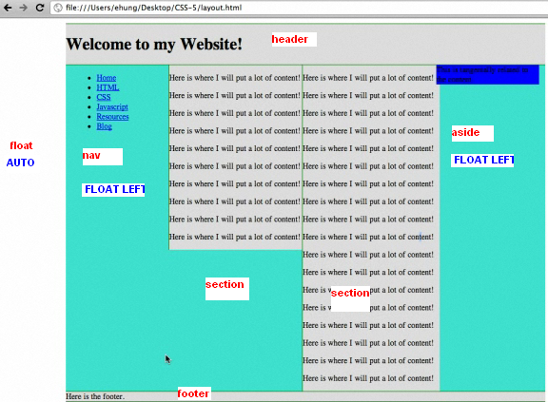

ALL ARE WITH BORDER, SOLID, DISPLAY, AND COLOR

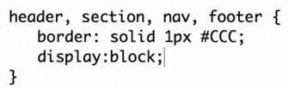

THE WHOLE CONTAINER IS TURQUOISE (GREEN AQUA), AND HAVE AUTO FLOAT TO THE RIGHT AND LEFT

WIDTH 700 TO CONTENT: NAV, 2 SECTIONS, ASIDE

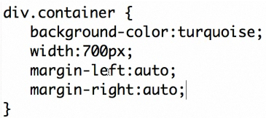

HEADER AND FOOTER WIDE

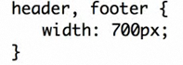

FOOTER, AVOID THE FLOAT FROM PREVIOUS SECTIONS

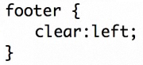

NAV, WITH AND FLOAT TO THE LEFT, DRAW BORDER RIGHT GREEN (150 FROM 700 OF THE DIV)

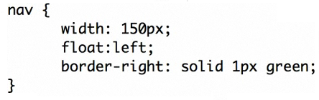

IT WILL NOT SHOW INDENTATION , ONLY THE FIRST OPTIONS IN NAV

-1

-1.2

-1.2.1

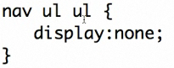

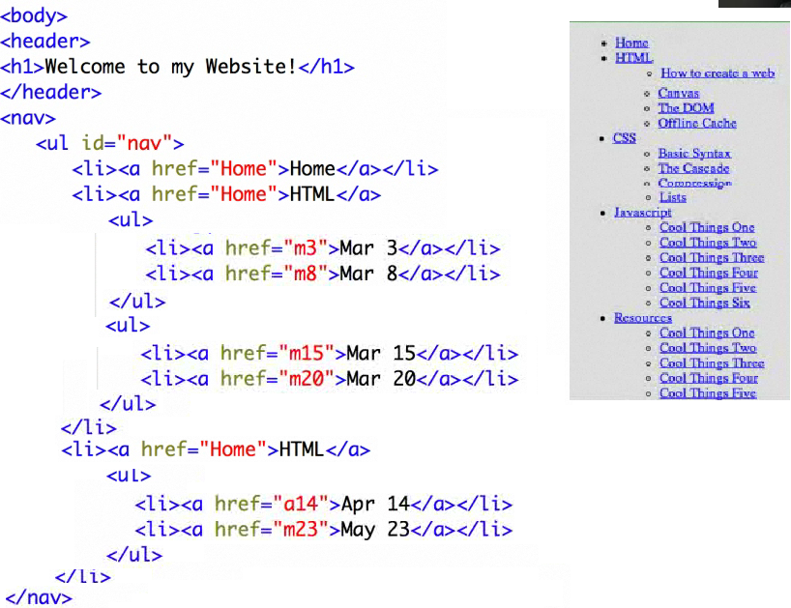

IT IS GOING TO BE 2 SECTIONS TO CREATE 2 COLUMNS (OVERFLOW: HIDDEN)

<section>

</section>

<section>

</section>

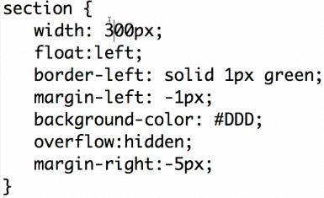

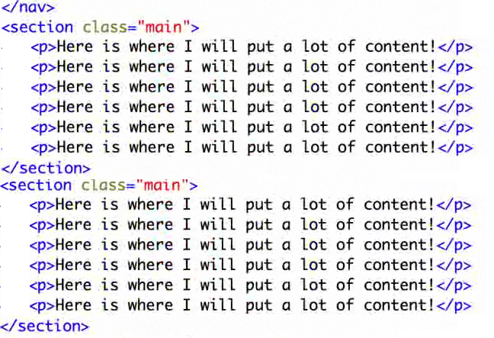

ASIDE: WIDHT 150 FROM 700, IT IS GOING TO BE BLUE, FLOAT LEFT

